7.5.1 – 7.5.3 Conics Worksheet

- Find the vertex, focus, and directrix of the graph .

Let’s first get our quadratic into vertex form by completing the square:
So
Vertex:
Focus:
Directrix:

- Suppose that a parabola has a vertex of and a directrix of .

Since the directrix of this parabola is given by the line $x=1$ the parabola opens left or right. Using the information we have we can obtain the following:
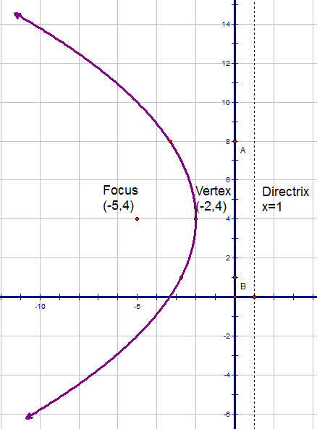

  - State the focus of this parabola
Focus:

  - Find the equation for the parabola

  - Carefully sketch a picture of this parabola. Label the vertex, directrix, focus, and plot at least 3 points.

- Consider the equation of a conic: .

  - Does this equation represent a parabola, ellipse, circle, or hyperbola?

So we see that this is the equation of a circle.

  - If this equation represents a parabola state its focus. If this equation represents an ellipse or hyperbola state its foci. If it is a circle state its center.

Center:

  - If this equation represents a parabola state is directrix. If this equation represents an ellipse or hyperbola state its vertices. If it is a circle state its radius.

Radius:

  - Carefully sketch a graph of the above equation.

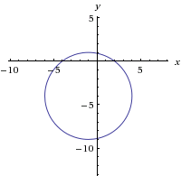

- Consider the equation of a conic:
  - Does this equation represent a parabola, ellipse, circle, or hyperbola?

So we see that this is the equation of an ellipse.

  - If this equation represents a parabola state its focus. If this equation represents an ellipse or hyperbola state its foci. If it is a circle state its center.

Since we see that the major axis in this ellipse is the horizontal.
Therefore the foci of this ellipse occur at the points: , where

So the foci occur at the points:

  - If this equation represents a parabola state is directrix. If this equation represents an ellipse or hyperbola state its vertices. If it is a circle state its radius.

The major axis is horizontal the vertices are a units in either direction from the center:
Vertices:

  - Carefully sketch a graph of the above equation.
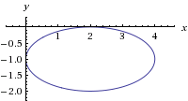

- Consider the equation of a conic:
  - Does this equation represent a parabola, ellipse, circle, or hyperbola?
So we see that this is the equation of a hyperbola.

  - If this equation represents a parabola state its focus. If this equation represents an ellipse or hyperbola state its foci. If it is a circle state its center.

Since we see that the transverse axis in this hyperbola is the horizontal.
Therefore the foci of this hyperbola occur at the points: , where

So the foci occur at the points:

  - If this equation represents a parabola state is directrix. If this equation represents an ellipse or hyperbola state its vertices. If it is a circle state its radius.

The transverse axis is horizontal the vertices are a units in either direction from the center:
Vertices:

  - Carefully sketch a graph of the above equation.

Our fundamental rectangle has corners of
Our asymptotes are given by the equations:

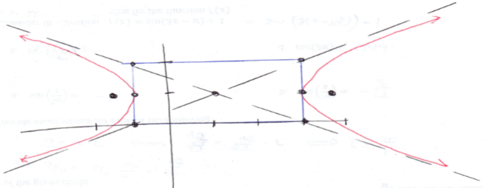

- Find an equation for the hyperbola with center , one focus at , and a vertex at .

By plotting the given points we can see that the hyperbola opens up and down.
Since our vertices are equally spaced from the center we can see that our other vertex is .
Since the vertices are given by the points when our hyperbola is centered at the origin they are now given by the points . Therefore .

The foci are given by the equation . Therefore we can determine that .
We know that , so we obtain:
So the equation of our hyperbola is:

- Consider the equation of a conic:
  - Does this equation represent a parabola, ellipse, circle, or hyperbola?

So we see that this is the equation of a circle.

  - If this equation represents a parabola state its focus. If this equation represents an ellipse or hyperbola state its foci. If it is a circle state its center.

Center:

  - If this equation represents a parabola state is directrix. If this equation represents an ellipse or hyperbola state its vertices. If it is a circle state its radius.

Radius:

  - Carefully sketch a graph of the above equation.

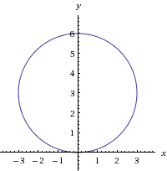

- Consider the equation:
  - Does this equation represent a parabola, ellipse, or hyperbola?

We can see that there is no $x^{2}$ term in this equation, so the equation must represent a parabola that opens left or right.

So we see that this is the equation of a parabola.
From this equation we can also identify the following values:

  - If this equation represents a parabola state its focus. If this equation represents an ellipse or hyperbola state its foci.

The focus of our parabola is given by the point:

  - If this equation represents a parabola state is directrix. If this equation represents an ellipse or hyperbola state its vertices.

The directrix of our parabola is given by the line:

  - Carefully sketch a graph of the above equation.

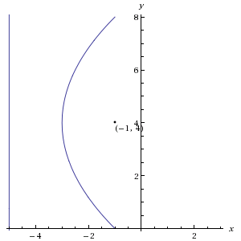

- Consider the conic given by the equation: .
  - Does this equation represent a parabola, ellipse, or hyperbola?

So we see that this is the equation of a hyperbola.

  - If this equation represents a parabola state its focus. If this equation represents an ellipse or hyperbola state its foci. If it is a circle state its center.
Since we see that the transverse axis in this hyperbola is the vertical.
Therefore the foci of this hyperbola occur at the points: , where

So the foci occur at the points:

  - If this equation represents a parabola state is directrix. If this equation represents an ellipse or hyperbola state its vertices. If it is a circle state its radius.

The transverse axis is vertical the vertices are a units in either direction from the center:
Vertices:
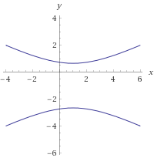
  - Carefully sketch a graph of the above equation.

Our fundamental rectangle has corners of
Our asymptotes are given by the equations:

